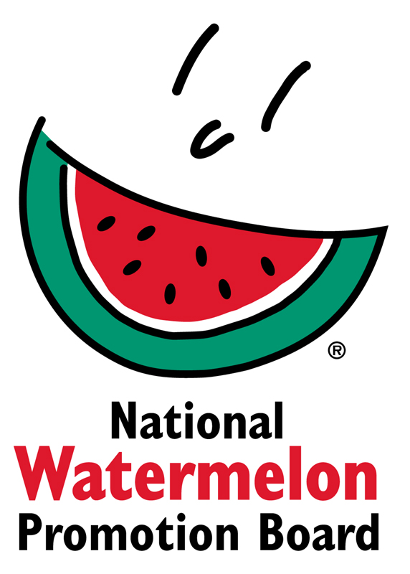

Media Contact:
Stephanie Barlow, 407-657-0261 ext. 202
sbarlow@watermelon.org

FOR IMMEDIATE RELEASE

Watermelon Recipe Contest Winners Use the Whole Watermelon

Winter Springs, FL (August 29, 2017) – With more than 125 entries, National Watermelon Promotion Board’s (NWPB) first-ever consumer recipe contest held during National Watermelon Month (July) wrapped up with sweet results.

The contest, themed “Use the Whole Watermelon,” challenged home cooks and chefs alike to think beyond the basic wedge. Categories included Flesh, Juice and Rind as a way to spotlight that every part of the watermelon can be used to create delicious dishes and beverages.

“Everyone loves biting into a sweet slice of watermelon – but many don’t know the rind is edible, or to use up extra watermelon in juices and smoothies,” said Stephanie Barlow, Senior Director of Communications. “Using the whole watermelon means less waste – and more fun in the kitchen!”

Entries ranged from “Rind Apple Pie” to “Golden Watermelon Gazpacho” – and with more than 25 percent of entries made up of rind recipes, it looks like home cooks are on board with the use-the-whole-watermelon trend.

The 2017 Use the Whole Watermelon winners are as follows:

Grand Prize
Watermelon Rind Kimchi Burger by Shauna Havey (Roy, Utah)

Flesh
Zesty Watermelon Chicken Salad Tortilla Cups by Shannon Kohn (Simpsonville, S.C.)

Juice
Lime-Mint Watermelon Granita with No-Churn Feta Ice Cream by Carmell Childs (Clawson, Utah)

Rind
Roasted Watermelon Rind Parmesan by Helen Fields (Paradise, Texas)

Honorable Mentions include:

Carne Guisada (Rind) by Greg Fontenot (The Woodlands, Texas)
Julienned Watermelon Rind Quiche (Rind) by Candy Barnhart (Makawao, Hawaii)
Lemon Basil Crunch Watermelon Custard (Flesh) by Juliana Evans (Wesley Chapek, Fla.)
Watermelon Jam (Juice) by Cheryl Holsapfel (Garrettsville, Ohio)

All the winning and honorable mentioned recipes will be added to the NWPB permanent collection on Watermelon.org. Look for the contest recipes, along with the release of new Watermelon Board recipes, in early 2018.

About National Watermelon Promotion Board
The National Watermelon Promotion Board, based in Winter Springs, Florida, was established in 1989 as an agricultural promotion group to promote watermelon in the United States and in various markets abroad. Funded through a self-mandated industry assessment paid by more than 1,500 watermelon producers, handlers and importers, NWPB mission is to increase consumer demand for watermelon through promotion, research and education programs. For additional information, visit www.watermelon.org.

