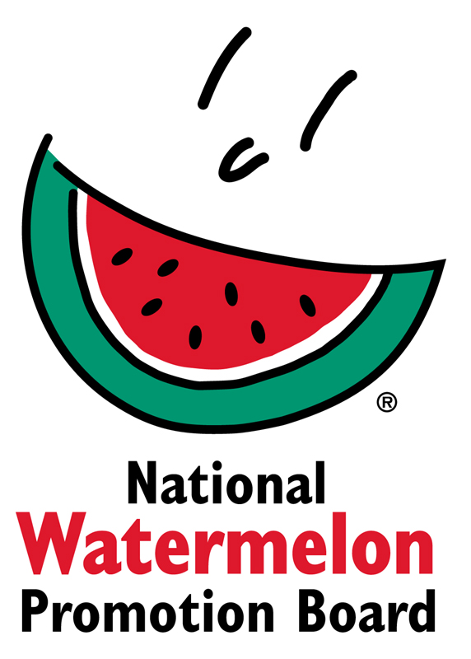

Media Contact:
Juliemar Rosado, 407-657-0261 X208
jrosado@watermelon.org

2017 Watermelon Retail Display Contest Winners Announced
Watermelon Board Awards Top Honors in Two Categories:
“Classic” and “Star-Spangled” Watermelon Displays

WINTER SPRINGS, FL – November 8, 2017 – Each year throughout the months of July and August the National Watermelon Promotion Board (NWPB) hosts a Retail Display Contest to help retailers drive watermelon sales. Now in its 9th year, the contest continues to grow with entries from retailers and commissaries in the United States and Canada, all creating displays showcasing watermelon’s health, value and versatility.

This year, more than 150 contest entries were submitted. Each entry was judged on overall appearance, creativity, use of NWPB-provided POS materials, “shop-ability” and messaging. A new format this year gave retailers the opportunity to win a grand prize in two categories – “Classic” and “Star Spangled” watermelon.

The grand prize winner in the “Classic” category is Trig’s located in Rhinelander, WI. The “Star-Spangled” watermelon grand prize winner is Travis AFB Commissary in Fairfield, CA. As the grand prize winners, Trig’s and Travis AFB will each receive $1,500. Additional prizes awarded for both categories include $800 for 2nd place winners, $600 for 3rd place winners and $400 for 4th place winners, respectively. Eight honorable mentions in each category were awarded $200 each.

A complete list of the winning displays, including photos, is attached. For more information, contact Juliemar Rosado at jrosado@watermelon.org.

About National Watermelon Promotion Board
The National Watermelon Promotion Board (NWPB), based in Winter Springs, Florida, was established in 1989 as an agricultural promotion group to promote watermelon in the United States and in various markets abroad. Funded through a self-mandated industry assessment paid by more than 1,500 watermelon producers, handlers and importers, NWPB mission is to increase consumer demand for watermelon through promotion, research and education programs.
Watermelon is a multivitamin unto itself, with each serving providing an excellent source of Vitamins A and C and a good source of Vitamin B6 with only 80 calories. Watermelon consumption per capita in the United States was an estimated 15.9 pounds in 2016. Watermelon consumption in the United States was approximately 5.1 billion pounds in 2016 according to Agricultural Marketing Service, an agency within the United States Department of Agriculture. The United States exported an additional 348.7 million pounds of watermelon. For additional information, visit www.watermelon.org.
###

