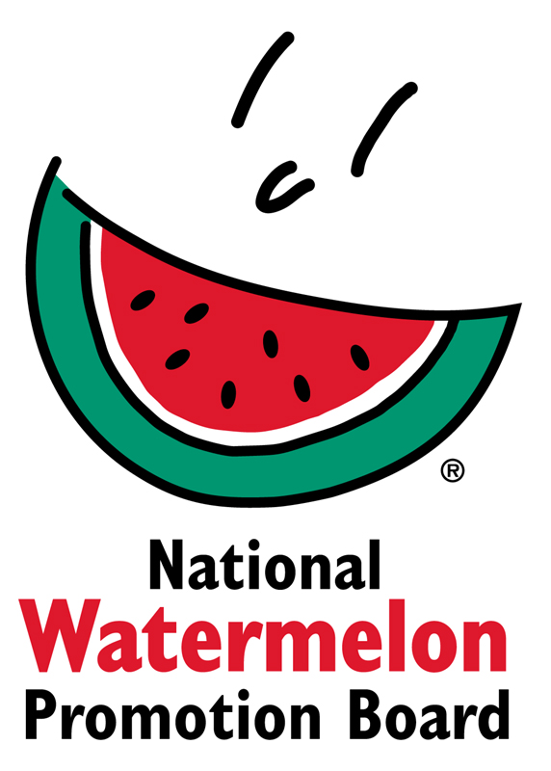
NEWS RELEASE
National Watermelon Promotion Board
FOR IMMEDIATE RELEASE

Contact: Stephanie Barlow, Senior Director of Communications
Phone: 407-657-0261 ext. 202
Email: sbarlow@watermelon.org

Boost in Views, Uses and Sales for Watermelon During 2018 Domestic Season
National Watermelon Promotion Board celebrates successes for consumer, retail and foodservice programs.

The National Watermelon Promotion Board’s (NWPB) strong focus on social media, digital marketing and strategic partnerships reached consumers and other produce-buying decision-makers for a successful 2018 domestic season.

“Digital and social channels are major vehicles for our programs,” explains Stephanie Barlow, senior director of communications for NWPB. “Additionally, we’ve seen success and increased sales when merchandising watermelon’s health, value and versatility in the produce aisle or on the menu.”

Watermelon fits consumers’ busy lifestyles
“During the domestic season, we put a heavy focus on the “Watermelon on the Go” campaign to show consumers that watermelon is a healthy and convenient choice even with a busy lifestyle,” says Barlow.

Video is recognized as a top medium for reaching consumers in a memorable way, and NWPB created more video content this year to capture the strong engagement.

Through 20 new recipe and how-to videos, the Watermelon on the Go campaign generated more than 150,000 native views across YouTube, Facebook and Instagram. “The on-the-go video campaign, combined with our educational Facebook Lives, which we host in-house, led to a growth of 28 percent on NWPB’s social media channels already this year. We’re really pleased to see this growth as there’s increased competition for viewership in these social spaces,” she says.

A national media tour on the same topic resulted in three social media videos filmed with Southern Living and Well Done, a video-based, social-only food publication, which were showcased across Time Inc.’s social media channels with one of the videos earning over 5.4 million total views.

Merchandising watermelon’s health benefits across North America
“For retail, we focused on promotions in our largest export market, supporting merchandising efforts and getting information about watermelon into the hands of supermarket dieticians,” says Juliemar Rosado, NWPB’s director of retail and international marketing.

The majority of the export market for U.S.-grown watermelons is Canada. “We did our groundwork before spring to make connections in the market, and it resulted in successful in-store promotions with five Canadian retailers when U.S. watermelon was in season,” adds Rosado.

To merchandise watermelon as a healthy lunch or after-school snack, NWPB partnered with Ibotta, a cash back rewards app, in a back-to-school promotion with a special offer on watermelon. This campaign was wildly successful with more than 2.9 million impressions, 136,000 engagements and 23,400 units moved in just four days.

NWPB also took this message to 500 retail dietitians across 58 retailers by participating in the Produce for Kids “We Heart RDs” program. The program involved inclusion of collateral materials in back-to-school kits as well as NWPB branded materials featured on the Produce for Kids website, e-newsletter and social media spaces.

Enticing menu items inspire chefs and lift foodservice profits
“Watermelon adds the ‘wow’ factor to the menu with many benefits to foodservice decision-makers,” says Megan McKenna.

In partnership with Another Broken Egg, a 64-location, daytime only restaurant chain, watermelon was offered as a side option, as well as in its Toasted Coconut Quinoa Power Skillet. The restaurant partnership resulted in a 126 percent increase in fruit sales and 305 percent increase in fruit side substitutes. “It’s clear watermelon can significantly lift sales,” says McKenna.

To reach out to chefs with education and inspiration, NWPB created a video series on how watermelon can be a versatile menu ingredient, including amping up global flavors on menus. The video series was then viewed during the Culinary Institute of America’s World’s of Flavor Webcast. Globally inspired recipe videos, such as North African Preserved Watermelon Chutney and Watermelon Rind Massaman Curry With Winter Vegetables, were aired during the webcast’s commercial breaks, gaining exposure with more than 175,000 views from foodservice professionals.

About National Watermelon Promotion Board
The National Watermelon Promotion Board (NWPB), based in Winter Springs, Florida, was established in 1989 as an agricultural promotion group to promote watermelon in the United States and in various markets abroad. Funded through a self-mandated industry assessment paid by more than 1,500 watermelon producers, handlers and importers, NWPB’s mission is to increase consumer demand for watermelon through promotion, research and education programs.

Watermelon packs a nutritious punch with each serving providing an excellent source of vitamin C, a good source of vitamin B6, and a delicious way to stay hydrated with only 80 calories. Watermelon consumption per capita in the United States was an estimated 16.3 pounds in 2017. Watermelon consumption in the United States was approximately 5.3 billion pounds in 2017. The United States exported an additional 339.1 million pounds of watermelon. For additional information, visit www.watermelon.org.

###

