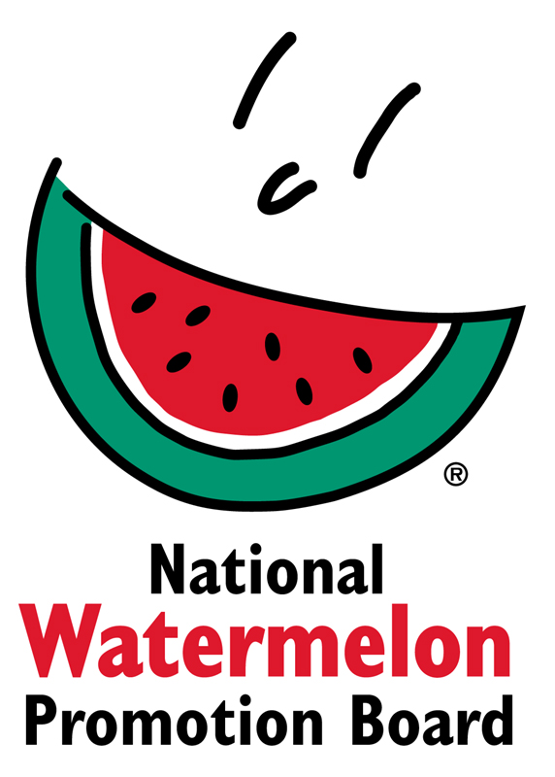

Media Contact:
Juliemar Rosado, 407-657-0261 X208
jrosado@watermelon.org

Watermelon Retail Display Contest Call for Entries
Celebrate National Watermelon Month and Watermelon Day!

WINTER SPRINGS, FL – July 19, 2019 – The National Watermelon Promotion Board (NWPB), invites all retail chains, independent retailers and commissaries with watermelons of U.S. origin to submit entries to their 11th annual Watermelon Retail Display Contest. Originally established to annually honor National Watermelon Month in July, the contest has expanded in recent years to celebrate National Watermelon Day on August 3rd and will run throughout the month. The contest is used by NWPB to encourage retailers to create displays that showcase the many benefits of watermelon including health, value and versatility.
More than $10,000 in cash and prizes will be awarded to top entrants, including “Classic” and “Star Spangled” watermelon categories. Winners in both categories will receive $1,500, $800 for 2nd place winners, $600 for 3rd place winners and $400 for both 4th place winners, respectively. Eight honorable mentions in each category will win $200 each. An additional incentive will be awarded to the first 25 entries.

Displays should promote watermelon of any kind, including whole, fresh-cut, mini watermelon, yellow and red or any mix thereof. Judges will consider a display’s overall appearance, creativity and shop-ability. Use of point-of-sale materials and/or selection and storage tips are encouraged to help elevate any retail display.

“According to our most recent consumer research *study, nutrition and selection information are the top two topics that drive purchase decisions,” commented Juliemar Rosado, Director of Retail Operations and International Marketing for the NWPB. “Combined with an eye-catching display, it’s a winning combination.”

To enter a display, retailers can submit their entry and photos via email or postal mail entry beginning July 8, 2019. All entries must be submitted/postmarked by midnight EST on September 9, 2019. Visit: http://watermelon.org/Retailers/Retail-Contest for more information, including official contest rules and entry form, or email NWPB at retail@watermelon.org.

About National Watermelon Promotion Board
The National Watermelon Promotion Board (NWPB), based in Winter Springs, Florida, was established in 1989 as an agricultural promotion group to promote watermelon in the United States and in various markets abroad. Funded through a self-mandated industry assessment paid by more than 1,500 watermelon producers, handlers and importers, NWPB mission is to increase consumer demand for watermelon through promotion, research and education programs.
Watermelon packs a nutritious punch, with each serving providing an excellent source of Vitamin C, a good source of Vitamin B6, and a delicious way to stay hydrated, with only 80 calories. Watermelon consumption per capita in the United States was an estimated 15.8 pounds in 2018. Watermelon consumption in the United States was approximately 5.2 billion pounds in 2018. The United States exported an additional 325.4 million pounds of watermelon. For additional information, visit www.watermelon.org.

*This survey was conducted online within the United States by Aimpoint on behalf of the NWPB in August of 2018 among 1,100 adults ages 18 or older that were the primary shoppers in the household.

