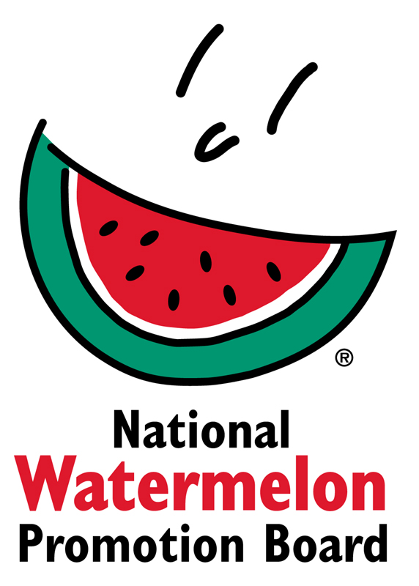

Media Contact:
Stephanie Barlow, 407-657-0261 ext. 202
sbarlow@watermelon.org

FOR IMMEDIATE RELEASE

Watermelon Board Hosts First-Ever Recipe Contest
Challenges Watermelon Fans to Use the Whole Watermelon
WINTER SPRINGS, FL – July 18, 2017 – To honor July as National Watermelon Month and in accordance with the 2017 campaign theme of “Use the Whole Watermelon,” the National Watermelon Promotion Board (NWPB), invites all fans of watermelon – novice and experienced chefs alike – to create original recipes for its inaugural recipe contest.

“The Board partnered with bloggers to inspire usage ideas and participation in the contest, and we hosted a #UseTheWholeWatermelon Twitter party to create momentum,” said Stephanie Barlow, Senior Director of Communications. “We also created social, consumable content and resources like tips, menus and blog posts.”
In addition to incorporating a variety of social media tactics, including organic and paid posts, the Board also created original content to use on a variety of strategic channels to grow entries. To encourage exploration on the topic and aid with conversation tracking, a new hashtag was used across social channels: #usethewholewatermelon.”
Recipe judging will be based on recipe taste and texture, prominent use of watermelon, creativity, originality and visual presentation/appearance. Four winners will be awarded including three first place prizes for each recipe category (flesh, juice, rind) to receive a $150 Visa gift card. One grand prize winner will receive a $500 visa gift card.

To enter a recipe in the contest, visit watermelon.org/recipecontest for official contest rules and to submit their entries. All entries must be received by midnight on July 31, 2017. There is no limit to recipe entries. For recipe inspiration, visit Watermelon Board’s Pinterest Board or the “Recipes” page on watermelon.org where new recipes are consistently added. For more inquiries, contact Stephanie Barlow, Senior Director of Communications at sbarlow@watermelon.org.

About National Watermelon Promotion Board
The National Watermelon Promotion Board, based in Winter Springs, Florida, was established in 1989 as an agricultural promotion group to promote watermelon in the United States and in various markets abroad. Funded through a self-mandated industry assessment paid by more than 1,500 watermelon producers, handlers and importers, NWPB mission is to increase consumer demand for watermelon through promotion, research and education programs. For additional information, visit www.watermelon.org.

###

