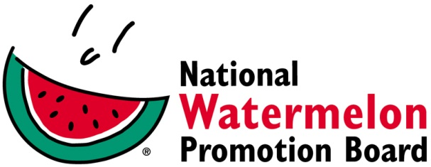

Media Contact:
Stephanie Barlow, 407-657-0261 X202
sbarlow@watermelon.org

FOR IMMEDIATE RELEASE

Watermelon Hydrates 2017 Marine Corps Marathon
Watermelon Board Delights Finishers and Fans Alike with
More Than 42,000 lbs. of Free Watermelon

WINTER SPRINGS, FL – November 3, 2017 –Nearly $25,000 worth of watermelon was given out by the National Watermelon Promotion Board (NWPB) to athletes and supporters 0f the 42nd Marine Corps Marathon. A source of citrulline and potassium with 92% water, watermelon was a post-race treat for sore and tired participants of the race, also known as the “People’s Marathon,” with participants from all 50 states and more than 60 countries.

The annual race took place this year on October 22 and is the largest marathon in the world that doesn’t offer prize money with more than 30,000 runners. Now a marathon mainstay, the Watermelon Board considers the race a perfect forum to communicate watermelon’s natural health benefits to runners and fans alike.

“Now in our 5th year, runners tell us they can’t wait to get their hands on the free watermelon at the finish,” said Stephanie Barlow, Senior Director of Communications at NWPB. “We go through an entire truckload of watermelon giving it out to the runners as well as their supporters. Each year more people tell us how much the watermelon was crucial to their recovery, the first step to replenishing the nutrients lost running 26.2 miles. They need to refuel if even just to get home and start repairing that immense wear and tear on the body. Watermelon is the perfect food to rehydrate, replenish and refuel whether you’re running the full marathon, 10K or cheering on a loved one.”

“They’ve really made the presence of watermelon into a welcome and expected element of the MCM finish experience. The Watermelon Board does great job with this platform and bringing prominence to their watermelon health messaging,” says Marc Goldman with the Marine Corps Marathon. “Their team and the queens bring great spirit and energy that conveys to the runners—both, marathoners and kids.”

In addition to the Sunday races, the Watermelon Board was also on hand at the Health & Fitness Expo on Friday and Saturday to educate attendees about watermelon as pre- and post-race fuel because of its electrolytes, nutrients and high water content. The big hit is the customizable watermelon cheer cards that supporters fill out with messages of encouragement for their runners. On Saturday, The national and several state watermelon queens were at the Healthy Kid’s Fun Run to serve sliced watermelon wedges to more than 3,600 participants from DC-area schools.

All of the watermelon distributed throughout the weekend was supplied by The Class Produce Group, a Maryland-based, family owned and operated produce wholesaler.

For more information about watermelon nutrition, including tips and resources, recipe ideas, and workouts, visit watermelon.org/watermelonforhealth.

About National Watermelon Promotion Board
The National Watermelon Promotion Board (NWPB), based in Winter Springs, Florida, was established in 1989 as an agricultural promotion group to promote watermelon in the United States and in various markets abroad. Funded through a self-mandated industry assessment paid by more than 1,500 watermelon producers, handlers and importers, NWPB mission is to increase consumer demand for watermelon through promotion, research and education programs.
Watermelon is a multivitamin unto itself, with each serving providing an excellent source of Vitamins A and C and a good source of Vitamin B6 with only 80 calories. Watermelon consumption per capita in the United States was an estimated 15.9 pounds in 2016. Watermelon consumption in the United States was approximately 5.1 billion pounds in 2016 according to Agricultural Marketing Service, an agency within the United States Department of Agriculture. The United States exported an additional 348.7 million pounds of watermelon. For additional information, visit www.watermelon.org.

###

