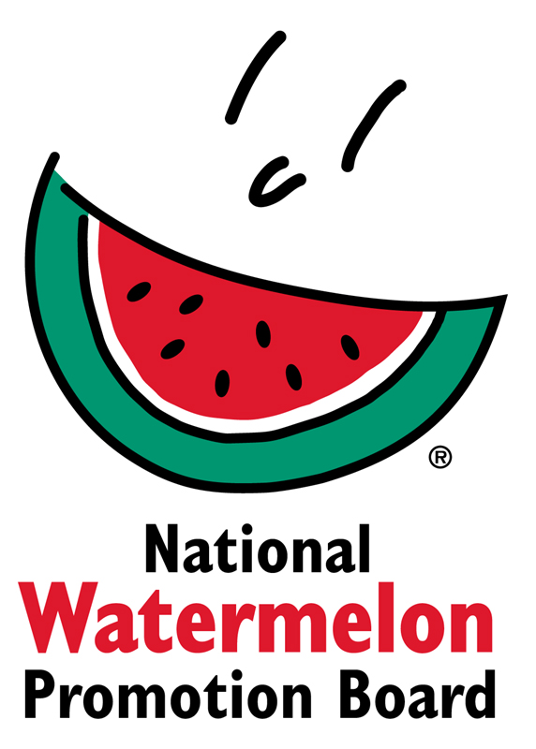
NEWS RELEASE
National Watermelon Promotion Board
FOR IMMEDIATE RELEASE

Contact: Stephanie Barlow, Senior Director of Communications
Phone: 407-657-0261 ext. 202
Email: sbarlow@watermelon.org

National Watermelon Promotion Board Prepares for Strong Production Year, Gears Up with Domestic Season Promotions

The table is set for more watermelon this season. Watermelon’s prevalence in the produce aisle, on restaurant tables and in consumers’ homes continues to strengthen and will be well supported by the coming domestic watermelon season.

Harvest is underway in Florida and Texas with initial reports from the field looking strong. Florida is shipping at above average tonnage for this time of year (up seven percent compared to 2017) with a 74 percent production increase versus 2017.

“Initial domestic harvest and shipping is underway in Florida and Texas. Overall watermelon shipments are slightly below the previous 5-year average for this time of the year, but that is subject to change as other areas around the country begin to ship and ramp up for what promises to be an excellent year for watermelons,” said Mark Arney, executive director and CEO, National Watermelon Promotion Board (NWPB).

To support the domestic season, NWPB is activating promotions to engage three core audiences: consumer, retailer and foodservice. Stephanie Barlow, senior director of communications for NWPB, shares, “It’s important that as watermelon hits the market, we reinforce our commitment to core audiences. That means continued education on the health benefits and ways to use watermelon and helping partners market during peak season.”

Consumer Campaigns
People would be surprised to know that the majority of watermelon is not consumed as a side dish at a summer barbecue or part of a refreshing cocktail, but as a snack according to 2017 NWPB consumer research. To get consumers to step up their snacking game, NWPB is introducing a “Watermelon On the Go” campaign theme this summer. The campaign will premiere on www.watermelon.org in time for peak season with a hub of “on the go” content and a series of videos with simple, snackable and portable recipe ideas.

NWPB is also taking on one of the biggest challenges consumers have with watermelons: handling its size. The NWPB team will visit editors at Time Inc. Food Studios for a watermelon butchery demo to showcase the many easy ways to carve and use a whole watermelon.

Retail Promotions
Good merchandising is important as it confirms the value and health benefits of watermelon. In fact, 87 percent of consumers say they are more likely to buy watermelon knowing it is healthy and nutritious. Helping to enforce this, the NWPB is engaging with NutriSavings, a digital nutrition wellness program. NutriSavings helps employers, supermarket retailers, health plans and food companies join forces to get employees and their families to shop, cook and eat healthier.

Returning for the 2018 domestic season is the NWPB retail display contest, which celebrates its 10-year anniversary. Open to all retail chains, independent retailers and commissaries, retailers create displays during July and August that showcase the many benefits of watermelon. Potential winnings include more than $10,000 in cash and prizes. To help with the construction of displays, the NWPB has merchandising kits — which include point-of-sales materials — available for retailers June 15-August 15. These kits can be ordered online, one per retail location. Retailers can also find a suite of resources for peak season at www.watermelon.org/Retailers.

Foodservice Outreach
Watermelon has a growing presence on the menus of restaurants across the U.S., appearing on one in 10 of menus and experiencing 27 percent growth in the past four years according to 2017 Datassential MenuTrends Research.

As part of its growth strategy, NWPB plans to partner with more hotel/entertainment foodservice establishments, which make up seven percent of the foodservice industry. Hotels with on-site restaurants are undergoing a renaissance to improve their menus and offerings to better compete with other restaurants in their area.

In 2018, NWPB is also commencing projects that will promote watermelon beyond summer. These initiatives include cutting and yield research on mini watermelons, which tend to increase in popularity during import season, and “Watermelon Year-Round: The Story” that aims to connect audiences to watermelon growers and their stories.

With the sequence of activations across audiences and the optimism surrounding the 2018 watermelon crop, Barlow projects a strong year across the board for the industry.

“The campaigns and promotions we’re launching will build demand for the increased watermelon volume available to consumers and provide support to our partners in the retailer and foodservice industries. Our dedicated team is continually creating fresh ways to think about and new opportunities to enjoy watermelon.”

About National Watermelon Promotion Board
The National Watermelon Promotion Board (NWPB), based in Winter Springs, Florida, was established in 1989 as an agricultural promotion group to promote watermelon in the United States and in various markets abroad. Funded through a self-mandated industry assessment paid by more than 1,500 watermelon producers, handlers and importers, NWPB mission is to increase consumer demand for watermelon through promotion, research and education programs.

Watermelon is a multivitamin unto itself, with each serving providing an excellent source of Vitamins A and C and a good source of Vitamin B6 with only 80 calories. Watermelon consumption per capita in the United States was an estimated 15.9 pounds in 2016. Watermelon consumption in the United States was approximately 5.1 billion pounds in 2016 according to Agricultural Marketing Service, an agency within the United States Department of Agriculture. The United States exported an additional 348.7 million pounds of watermelon. For additional information, visit www.watermelon.org.

