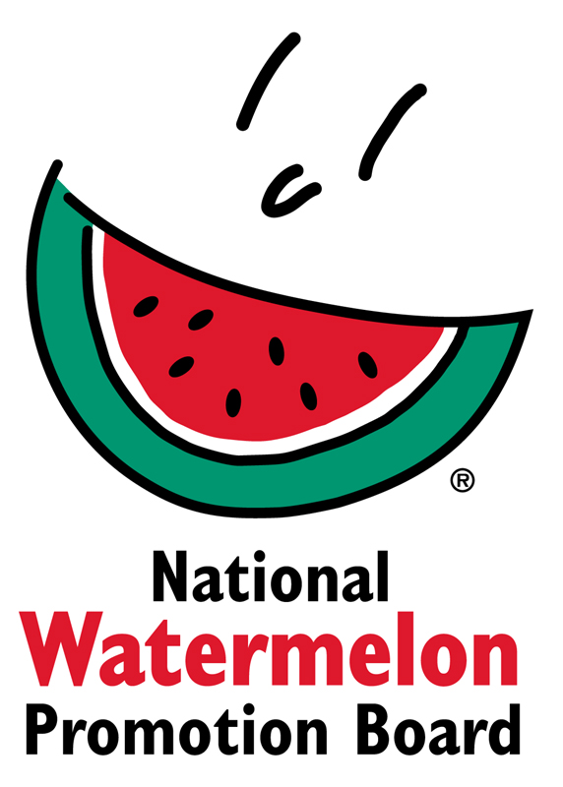
NEWS RELEASE
National Watermelon Promotion Board
FOR IMMEDIATE RELEASE

Contact: Stephanie Barlow, Senior Director of Communications
Phone: 407-657-0261 ext. 202
Email: sbarlow@watermelon.org

National Watermelon Promotion Board Takes Watermelon-on-the-Go for Media Event
Food editors learn tips for using watermelon in a variety of portable snacks

Convenient and portable may not be the first qualities that come to mind when you think of a big, whole watermelon. However, the National Watermelon Promotion Board (NWPB) is challenging that thinking and creating new occasions for eating watermelon.

NWPB recently visited Time Inc. Food Studios in Birmingham, Ala., to demonstrate endless ideas for watermelon-on-the-go as breakfast, snacks, lunches and beverages. The media event drew attendance from food editors and recipe developers from Time Inc.’s 11 different brands, including Southern Living, Cooking Light, Health and Real Simple. At the test kitchen, NWPB conducted a watermelon butchery demo, cutting wedges, sticks and diced watermelon from the flesh, blending it for juice and even using the edible rind for zero waste.

“Snacking and on-the-go eating occasions are on the rise with consumers’ busy lifestyles. We showed food editors how one watermelon offers various cuts and can create multiple simple and portable recipes,” said Stephanie Barlow, NWPB senior director of communications. “We can’t wait to see how the demonstration and menu samples inspire future editorial content and recipes.”

About National Watermelon Promotion Board

The National Watermelon Promotion Board (NWPB), based in Winter Springs, Florida, was established in 1989 as an agricultural promotion group to promote watermelon in the United States and in various markets abroad. Funded through a self-mandated industry assessment paid by more than 1,500 watermelon producers, handlers and importers, NWPB mission is to increase consumer demand for watermelon through promotion, research and education programs.

Watermelon packs a nutritious punch, providing vitamin C, vitamin A and vitamin B6, with only 80 calories per serving. Watermelon consumption per capita in the United States was an estimated 15.9 pounds in 2016. Watermelon consumption in the United States was approximately 5.1 billion pounds in 2016 according to Agricultural Marketing Service, an agency within the United States Department of Agriculture. The United States exported an additional 348.7 million pounds of watermelon. For additional information, visit www.watermelon.org.
###
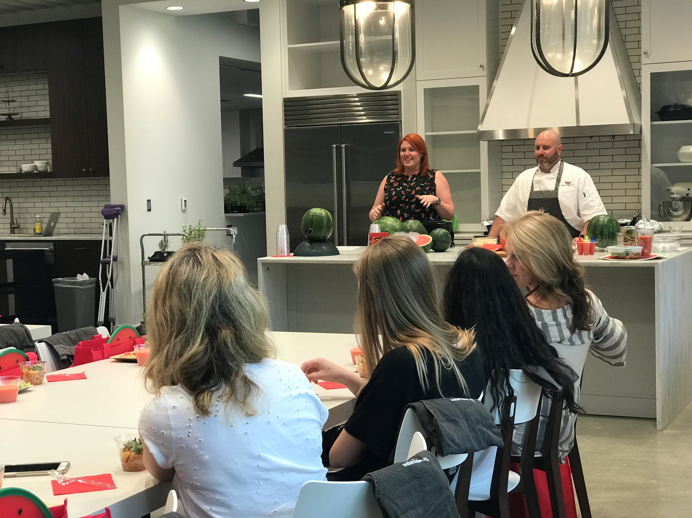
Cutline #1:
Chef Dave Woolley and NWPB's Stephanie Barlow led a watermelon butchery demonstration at Time Inc. Food Studios on how to use the whole watermelon, including its flesh, juice and rind.
Download image of demonstration with Chef Woolley and Stephanie Barlow.
Download image of various watermelon cuts.
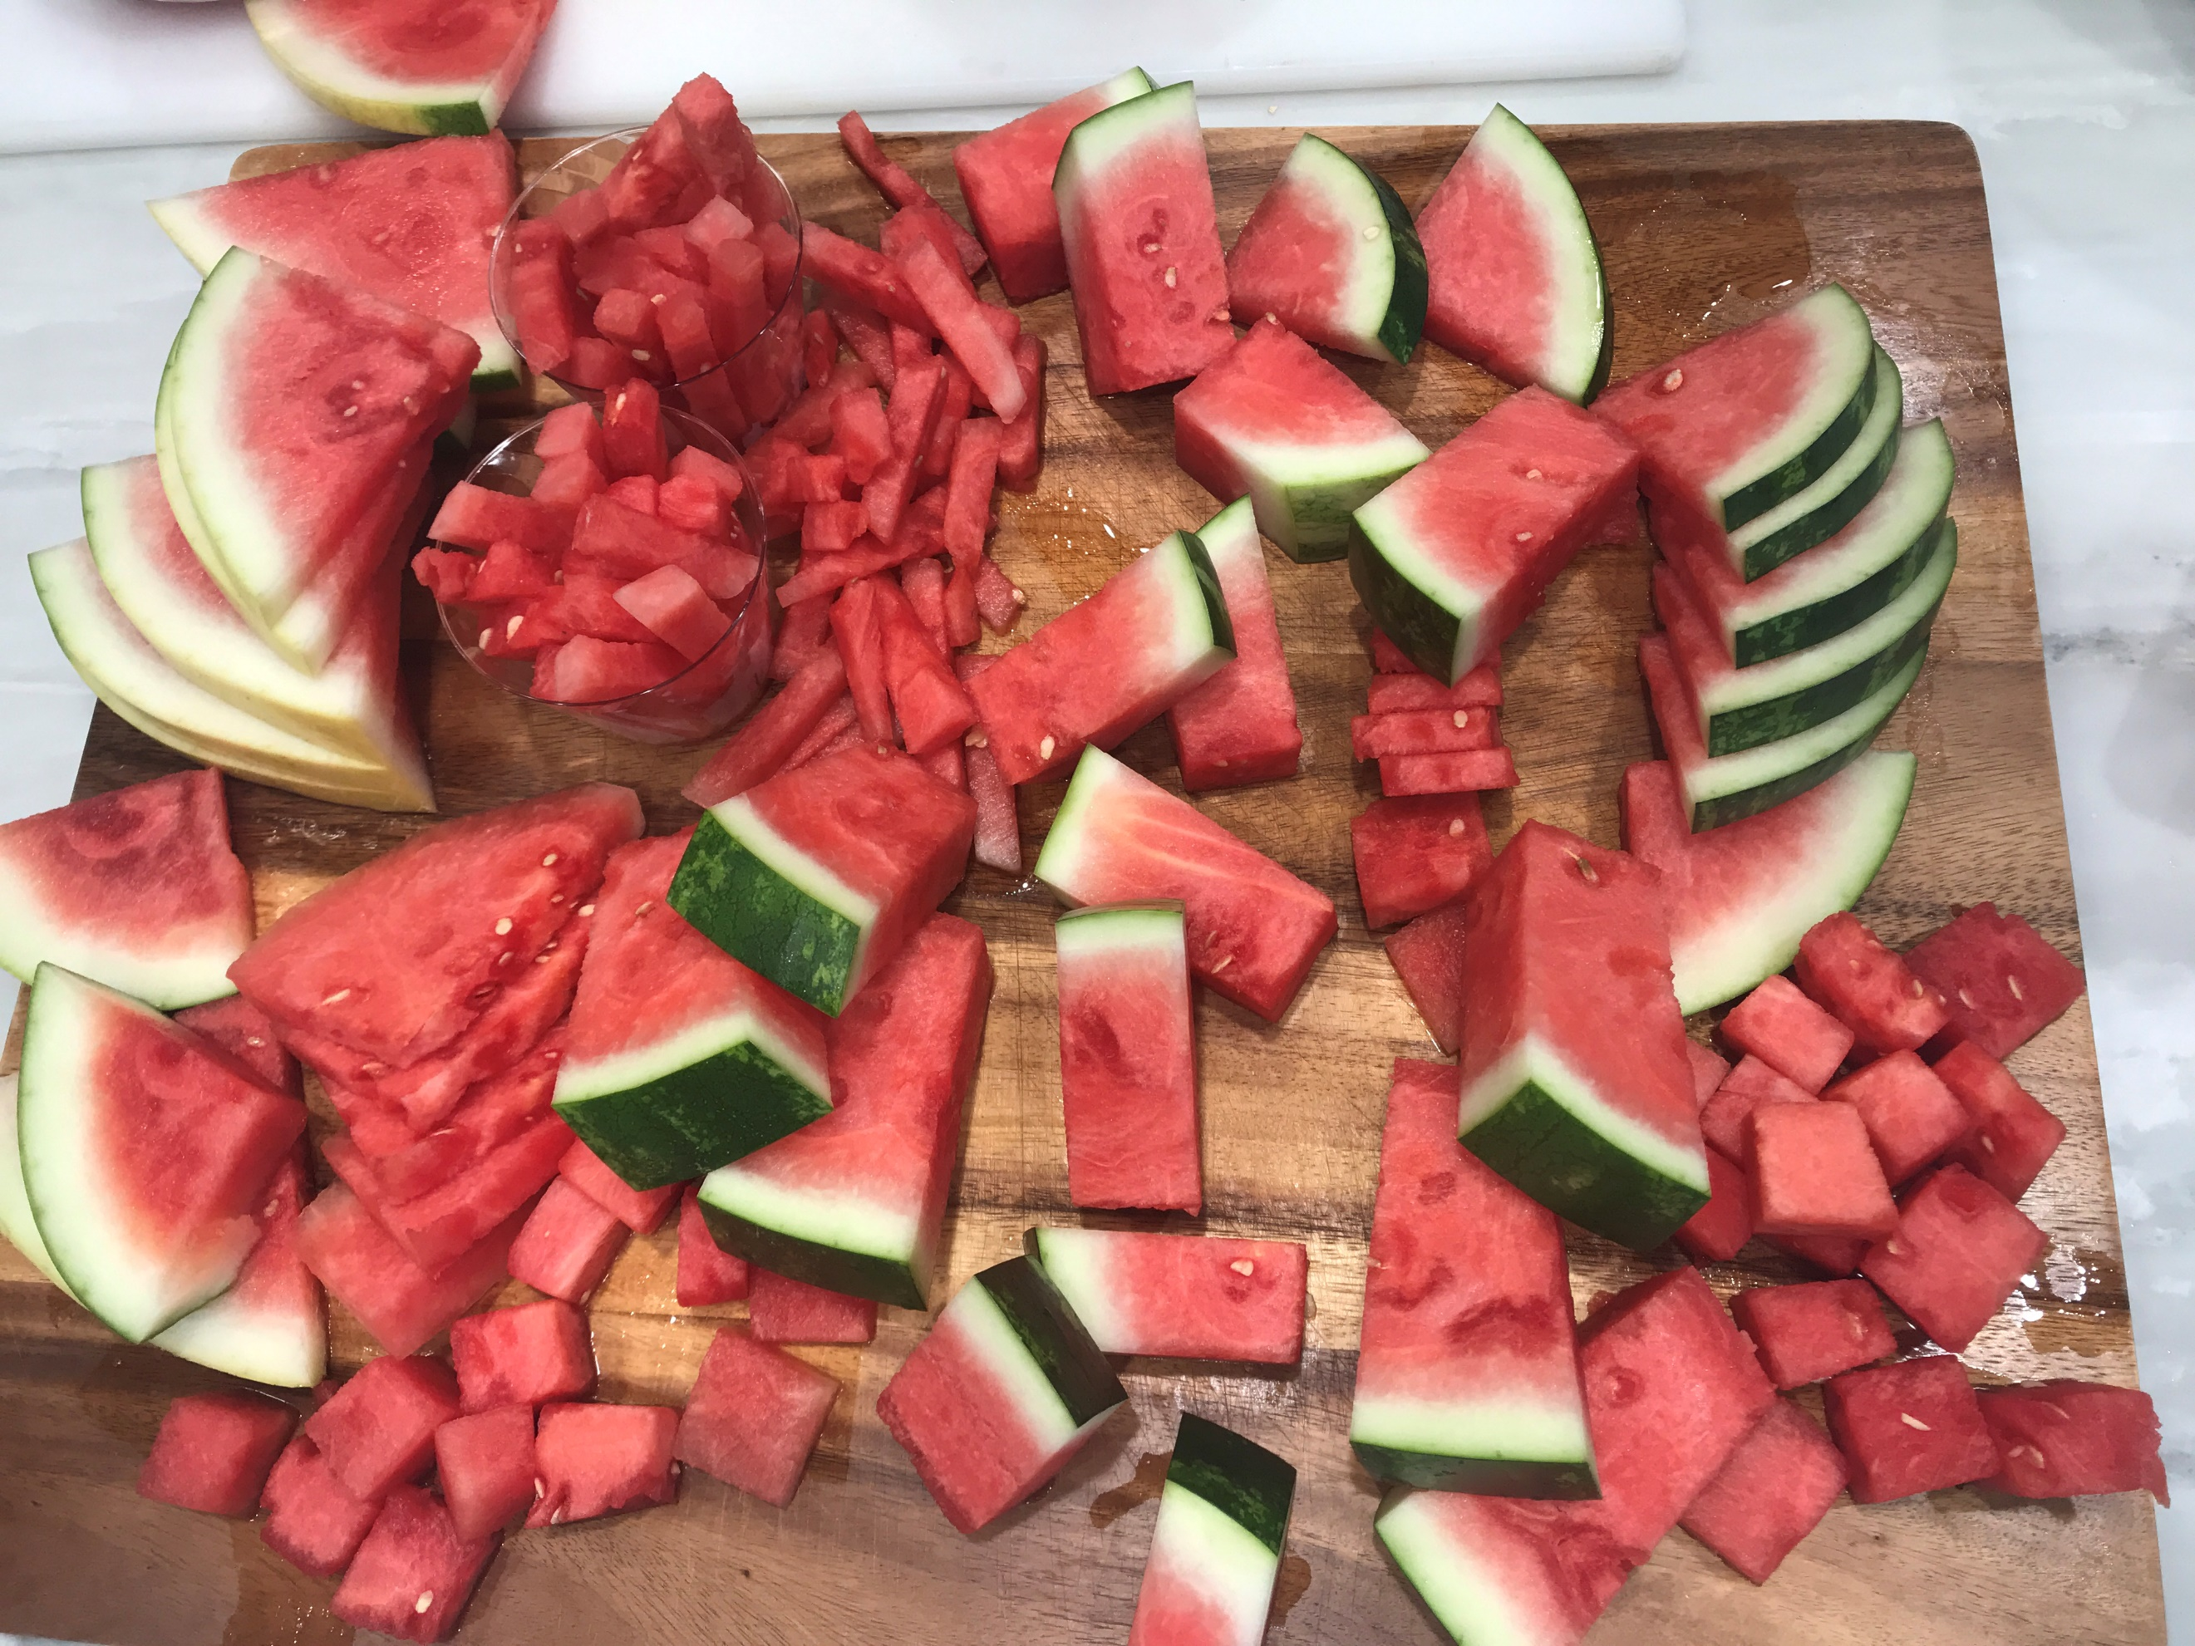

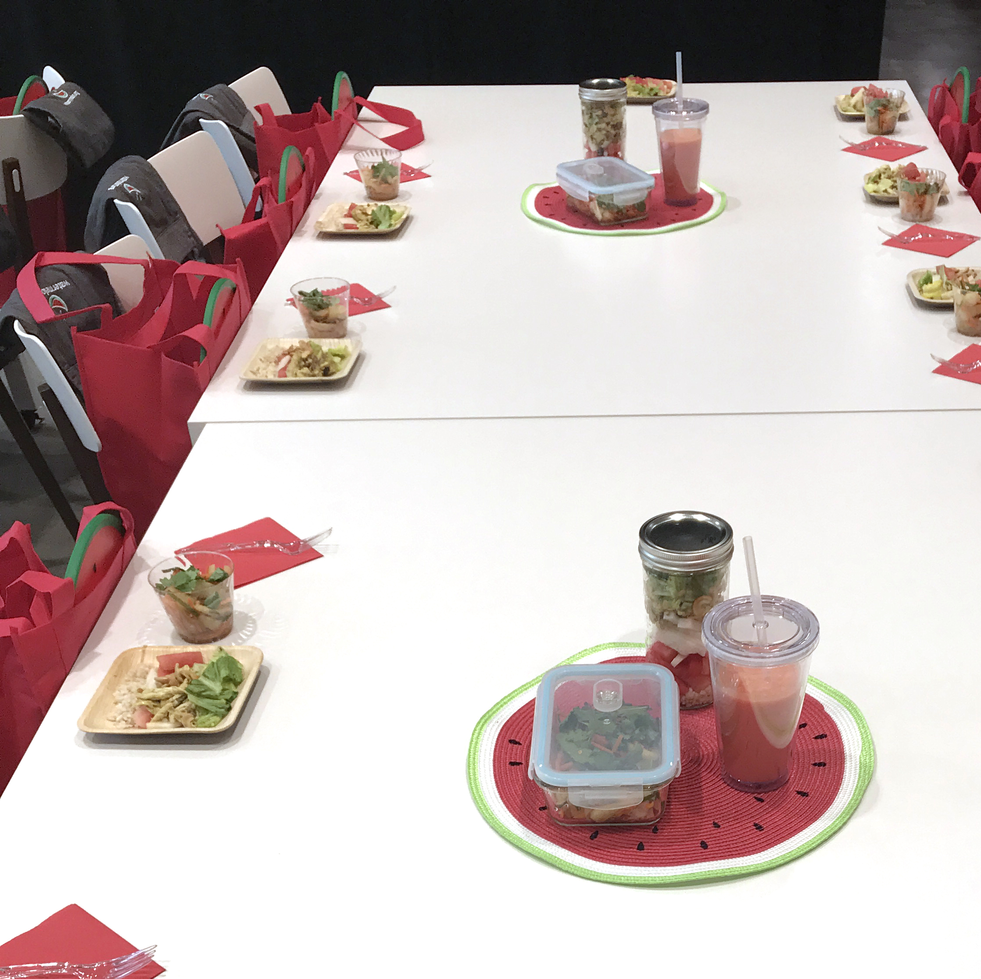
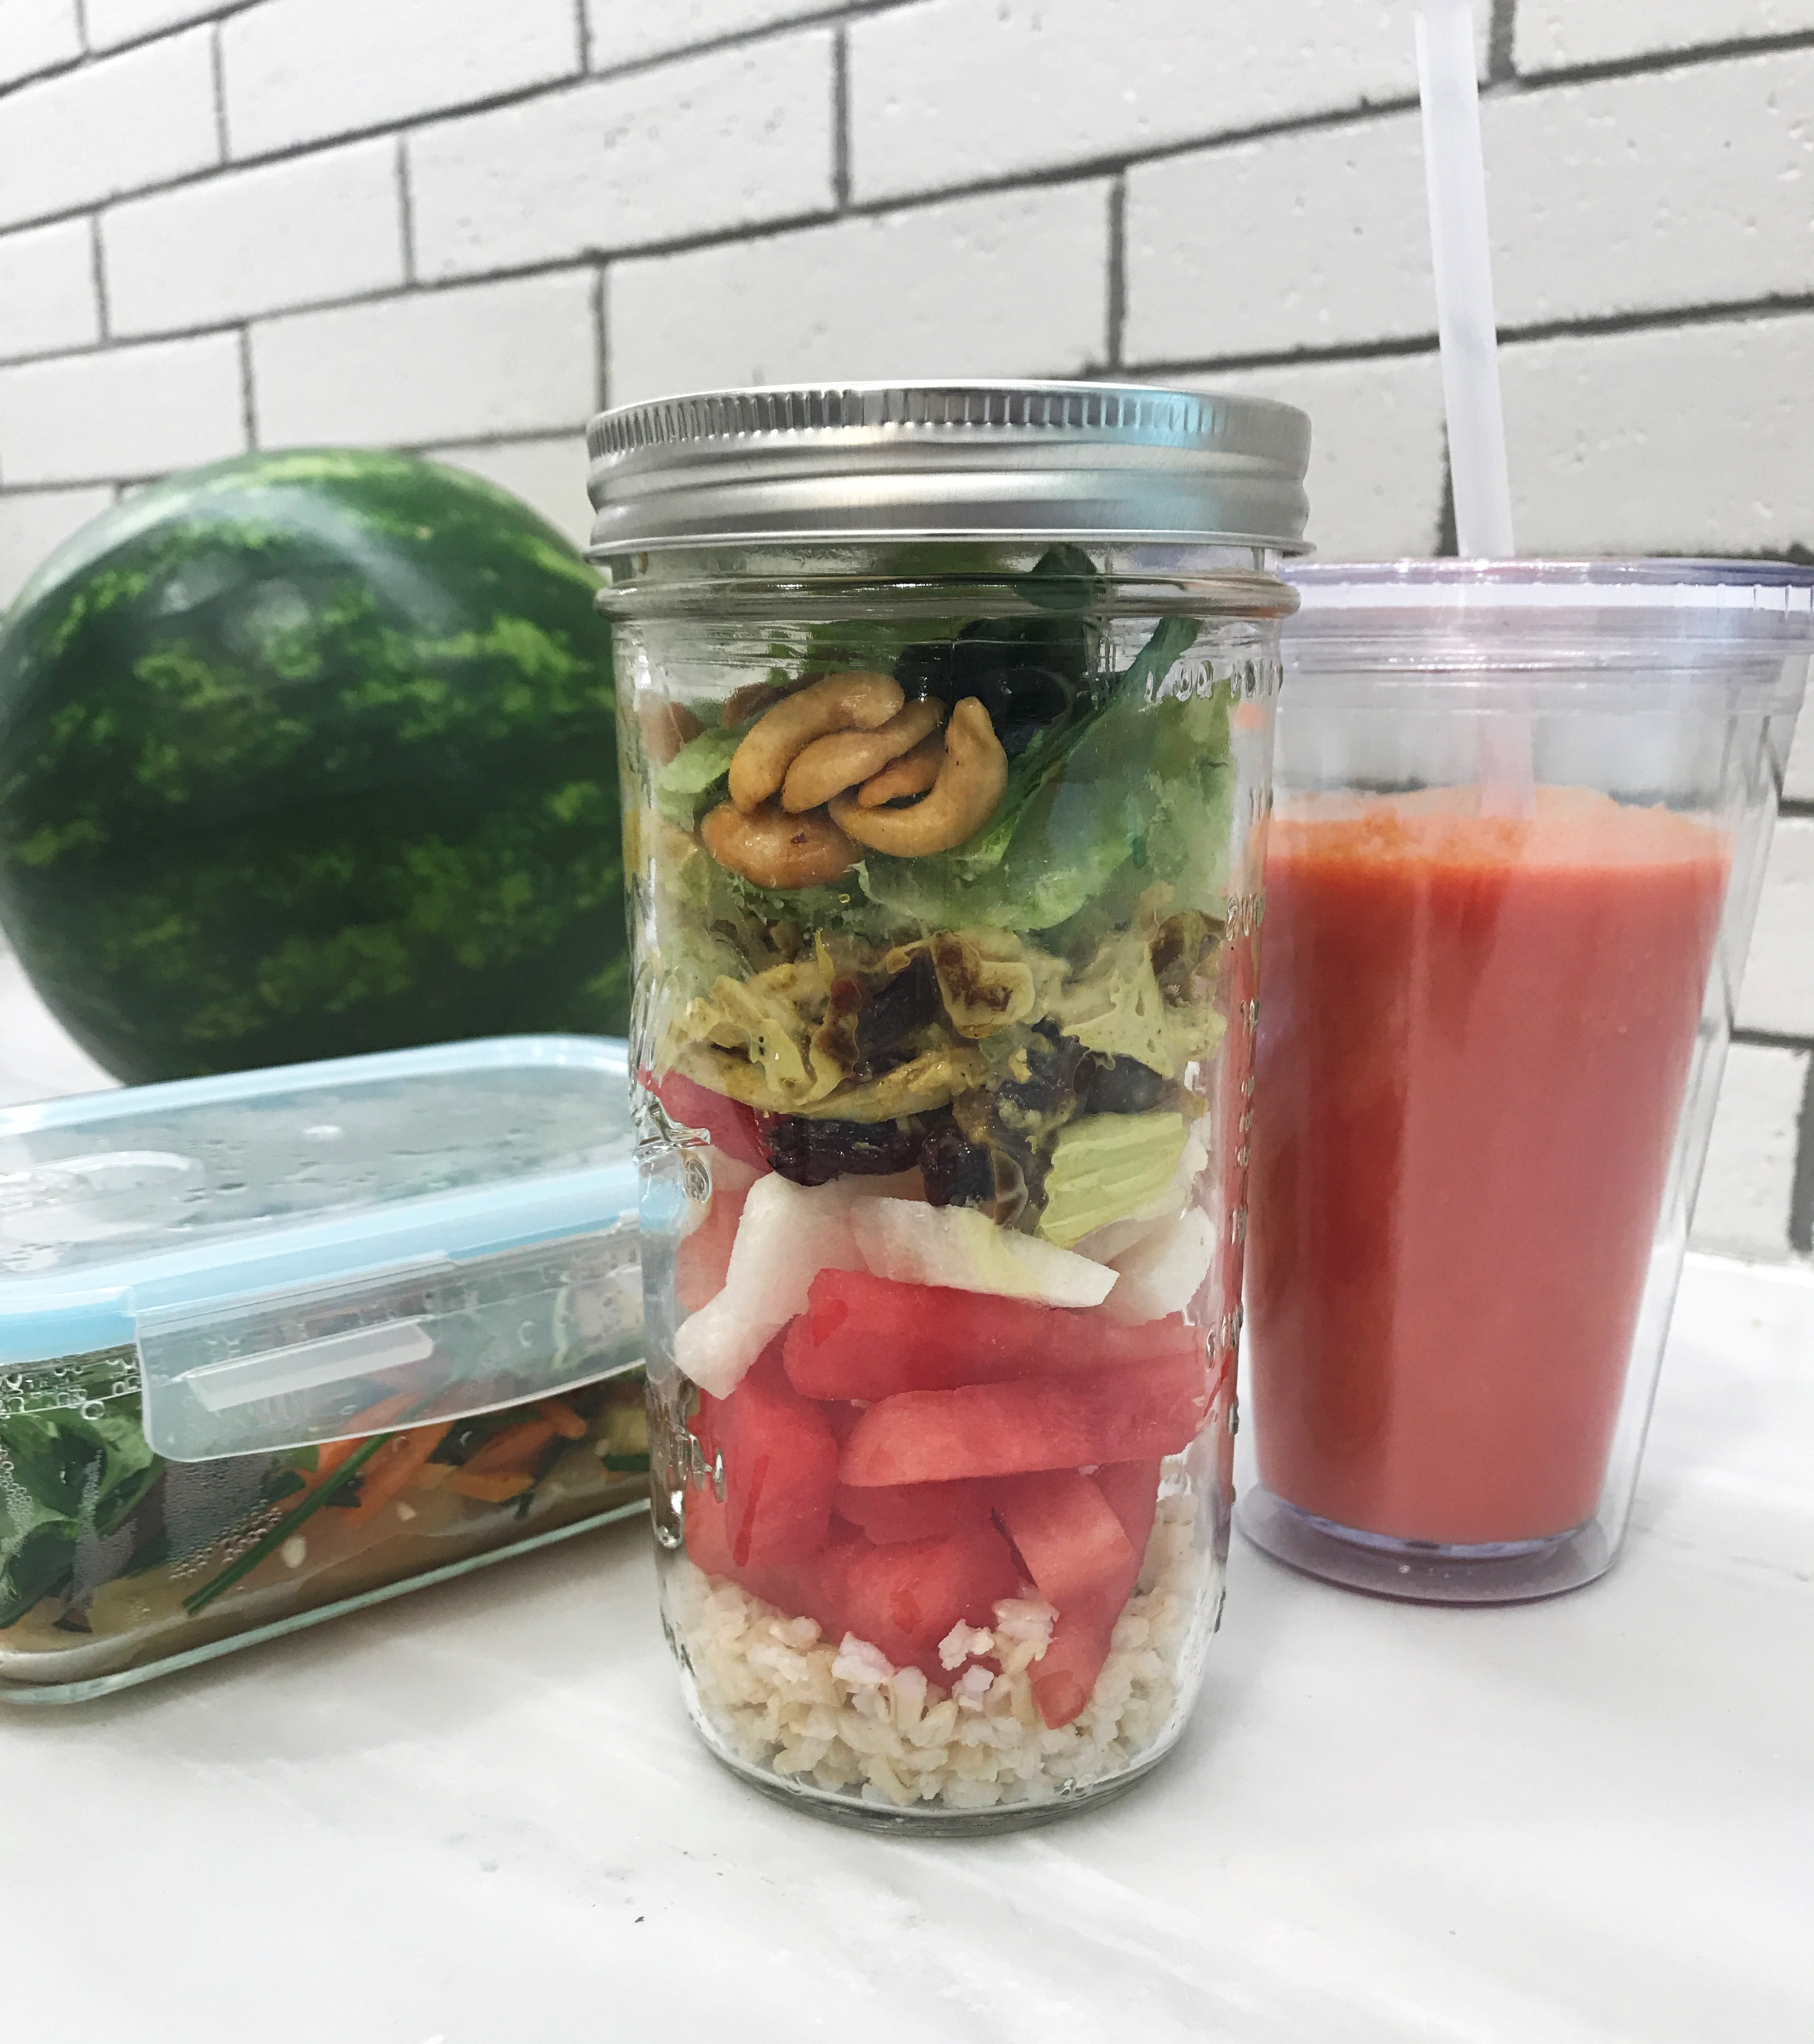
Cutline #2:
NWPB presented food media with a menu of portable watermelon options. The tasting menu included Stacked Watermelon and Jicama Chicken Salad in a Mason jar, Watermelon Collagen Smoothie in a to-go cup, and Watermelon Rind Stir Fry in a reusable lunch container.
Download photo of watermelon salad in Mason jar.
Download photo of table set with menu samples for Time Inc. food media.

