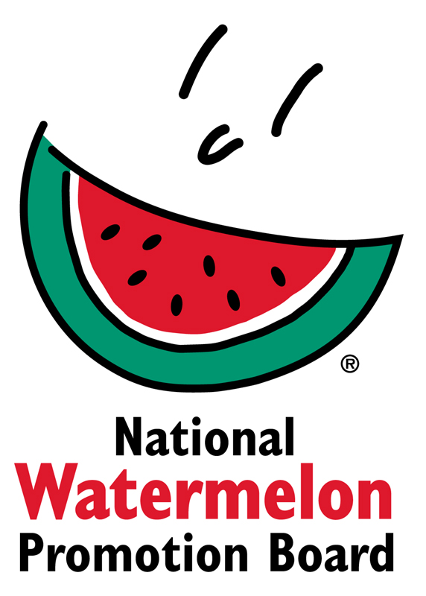
NEWS RELEASE
National Watermelon Promotion Board
FOR IMMEDIATE RELEASE

Contact: Stephanie Barlow, Senior Director of Communications
Phone: 407-657-0261 ext. 202
Email: sbarlow@watermelon.org

National Watermelon Promotion Board Launches Its “Watermelon on the Go” Digital Campaign

Campaign content is delivered in bite-sized and shareable formats for consumers.

In its newest digital consumer campaign, the National Watermelon Promotion Board (NWPB) proposes watermelon as the perfect portable companion for busy summer schedules.

“With our Watermelon on the Go campaign, we’re showing consumers how easy it is to pack the taste of summer into a multitude of watermelon recipes fit for picnic blankets, beach snacks or grab-and-go breakfasts,” explains Stephanie Barlow, NWPB senior director of communications.

The online hub for Watermelon on the Go (https://www.watermelon.org/watermelononthego) guides consumers with how-to videos for prepping watermelon sticks, cubes, rinds and juice. With these foundational cuts, consumers can assemble simple recipes that travel well.

As a taste of the content, NWPB shares the following make-and-take ideas:
- Fill a sport bottle with Watermelon-Infused Water for refreshing hydration.
- Take Watermelon Dippers to the beach as an excellent snack.
- Pack a glass canning jar with Stacked Watermelon Chicken Salad as a healthy lunch for a workday or road trip.

“For the Watermelon on the Go campaign, we created 18 new videos. Just as consumers need simple recipes that fit their busy lifestyles, we needed to deliver our best how-tos in a bite-sized format of just 60 seconds or less,” notes Barlow.

Starting July 9, 25 influencers will lead a #WatermelonOnTheGo conversation on their blogs and social media to provide even more recipe inspiration for consumers. The #WatermelonOnTheGo campaign can be found across NWPB’s social channels (@WatermelonBoard), including Facebook, Twitter, Pinterest, YouTube and Instagram.
####

About National Watermelon Promotion Board
The National Watermelon Promotion Board (NWPB), based in Winter Springs, Florida, was established in 1989 as an agricultural promotion group to promote watermelon in the United States and in various markets abroad. Funded through a self-mandated industry assessment paid by more than 1,500 watermelon producers, handlers and importers, NWPB’s mission is to increase consumer demand for watermelon through promotion, research and education programs.

Watermelon packs a nutritious punch with each serving providing an excellent source of vitamin C, a good source of vitamin B6 and a delicious way to stay hydrated with only 80 calories. Watermelon consumption per capita in the United States was an estimated 16.3 pounds in 2017or approximately 5.3 billion pounds. The United States exported an additional 339.1 million pounds of watermelon. For additional information, visit www.watermelon.org.

