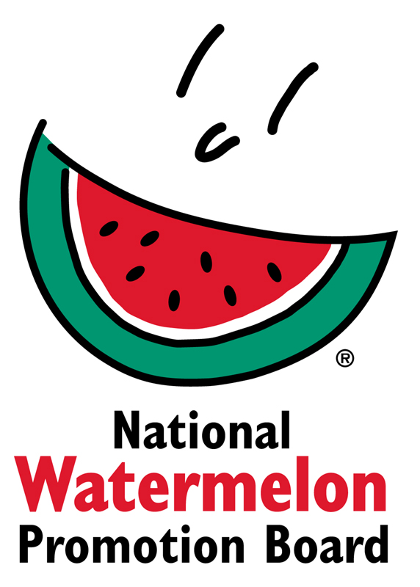
NEWS RELEASE
National Watermelon Promotion Board
FOR IMMEDIATE RELEASE

Contact: Stephanie Barlow, Senior Director of Communications
Phone: 407-657-0261 ext. 202
Email: sbarlow@watermelon.org

“Watermelon Mile” Marks Watermelon’s Healthy Attributes
National Watermelon Promotion Board provides 5,000 servings to refuel runners

Runners were rewarded with hydrating watermelon at the “Watermelon Mile” of the Fit Foodie Festival and 5K in Denver. As an event sponsor, the National Watermelon Promotion Board provided more than 5,000 watermelon servings during the run and festival to showcase watermelon’s health, value and versatility. In addition, Chef Dina Paz demonstrated how to make the Watermelon Bulgur Wheat Salad on the Culinary Stage.

“The Fit Foodie Run was an excellent venue to reach fitness-focused consumers and their families. With the variety of watermelon applications offered, including juice, wedge pops and salads, attendees appreciated having a nutritious whole food to refuel and take on the go,” says Stephanie Barlow, senior director of communications, National Watermelon Promotion Board.

About National Watermelon Promotion Board
The National Watermelon Promotion Board (NWPB), based in Winter Springs, Florida, was established in 1989 as an agricultural promotion group to promote watermelon in the United States and in various markets abroad. Funded through a self-mandated industry assessment paid by more than 1,500 watermelon producers, handlers and importers, NWPB’s mission is to increase consumer demand for watermelon through promotion, research and education programs.

Watermelon packs a nutritious punch with each serving providing an excellent source of vitamin C, a good source of vitamin B6 and a delicious way to stay hydrated with only 80 calories. Watermelon consumption per capita in the United States was an estimated 16.3 pounds in 2017or approximately 5.3 billion pounds. The United States exported an additional 339.1 million pounds of watermelon. For additional information, visit www.watermelon.org.
###

Downloadable photos for media use: https://flm.egnyte.com/fl/2xcZi6shK2

