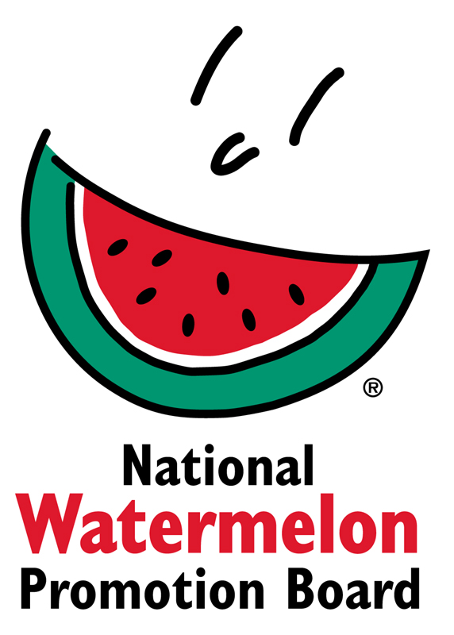

Media Contact:
Juliemar Rosado, 407-657-0261 X208
jrosado@watermelon.org

2018 Watermelon Retail Display Contest Winners Announced
Watermelon Board Awards Top Honors in Two Categories:
“Classic” and “Star-Spangled” Watermelon Displays

WINTER SPRINGS, FL – October 26, 2018 – Each year throughout the months of July and August the National Watermelon Promotion Board (NWPB) hosts a Retail Display Contest to help retailers drive watermelon sales. Now in its 10th year, the contest continues to grow with entries from retailers and commissaries in the United States and Canada, all creating displays showcasing watermelon’s health, value and versatility.

This year, more than 150 contest entries were submitted. Each entry was judged on overall appearance, creativity, use of NWPB-provided POS materials, “shop-ability” and messaging.
“This year’s entries were incredible,” said Juliemar Rosado, director of retail operations and international marketing. “The stores didn’t just meet the judging criteria, they went above and beyond. Judging was very tough this year.”

The grand prize winner in the “Classic” category is Nellis AFB Commissary located in Las Vegas, NV. The “Star-Spangled” watermelon grand prize winner is MacDill AFB Commissary in Tampa, FL. "DeCA Commissaries continue to show strong support and creative efforts in NWPB’s promotions. Promotions that encourage our stores in building creative mass displays assist in providing our patrons with a fun and exciting shopping experience, as well as providing opportunities for increased sales throughout the store, while also increasing the probability of returning patrons,” said Judith Wamback, produce merchandising specialist for the DeCA commissaries.

As grand prize winners, Nellis and MacDill will each receive $1,500 in prizes. Additional prizes awarded for both categories include $800 for 2nd place winners, $600 for 3rd place winners and $400 for 4th place winners, respectively. Eight honorable mentions in each category were awarded $200 each.

A complete list of the winning displays, including photos, is attached. For more information, contact Juliemar Rosado at jrosado@watermelon.org.

About National Watermelon Promotion Board
The National Watermelon Promotion Board (NWPB), based in Winter Springs, Florida, was established in 1989 as an agricultural promotion group to promote watermelon in the United States and in various markets abroad. Funded through a self-mandated industry assessment paid by more than 1,500 watermelon producers, handlers and importers, NWPB mission is to increase consumer demand for watermelon through promotion, research and education programs.

Watermelon packs a nutritious punch with each serving providing an excellent source of vitamin C, a good source of vitamin B6 and a delicious way to stay hydrated with only 80 calories. Watermelon consumption per capita in the United States was an estimated 16.3 pounds in 2017 or approximately 5.3 billion pounds. The United States exported an additional 339.1 million pounds of watermelon. For additional information, visit www.watermelon.org.

###

