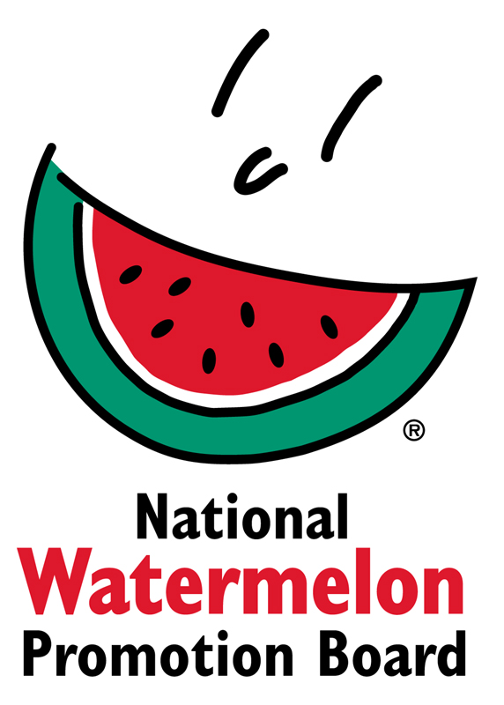**NEWS RELEASE**

**National Watermelon Promotion Board**

**FOR IMMEDIATE RELEASE**

Contact: Stephanie Barlow, Senior Director of Communications

Phone: 407-657-0261 ext. 202

Email: [sbarlow@watermelon.org](mailto:sbarlow@watermelon.org)

**NWPB Announces Watermelon Resource Available for Registered Dietitians**

*Registered dietitians can explore the “Wide World of Watermelon” for ready-to-use facts and ideas tailored to their practice area.*

**Winter Springs, Fl. – June 2019 –** The National Watermelon Promotion Board (NWPB) announces a newly developed “Wide World of Watermelon Registered Dietitian Toolkit.” The toolkit offers resources tailored for specific RD practice areas including media and communications, school nutrition, retail and supermarket, sports dietetics, private practice and foodservice.

“Dietitians are trained in nutrition science and fundamentally know that watermelon is a healthy choice. The toolkit goes beyond nutrition to package information and ideas that practicing RDs can implement in a variety of settings, from media and communications to school or sports nutrition,” shares Stephanie Barlow, NWPB senior director of communications.

The Wide World of Watermelon Registered Dietitian Toolkit makes it easy for RDs to find watermelon’s health benefits, versatility, selection and preparation tips, story and demonstration ideas for every season, flavor pairings and other key facts. The digital resource, available at [Watermelon.org/Nutrition](https://watermelon.org/Nutrition), also provides links to recipes, articles, cutting and yield infographics, MyPlate guidelines and other educational tools.

“As a nutrition professional focused on sports training, watermelon is a great fit to support active individuals in exercise and body repair. With the toolkit from NWPB, key messages and resources about watermelon as a source of potassium and L-citrulline, for example, are at my fingertips,” comments Chrissy Carroll, MPH, RD, LDN, ACSM-CPT, USAT Level I triathlon coach.

The new RD toolkit was launched at the recent Today’s Dietitian Symposium and is being promoted to a variety of dietetic practice groups.

**About National Watermelon Promotion Board**

The National Watermelon Promotion Board (NWPB), based in Winter Springs, Florida, was established in 1989 as an agricultural promotion group to promote watermelon in the United States and in various markets abroad. Funded through a self-mandated industry assessment paid by more than 1,500 watermelon producers, handlers and importers, NWPB’s mission is to increase consumer demand for watermelon through promotion, research and education programs.

Watermelon packs a nutritious punch with each serving providing an excellent source of vitamin C, a good source of vitamin B6 and a delicious way to stay hydrated with only 80 calories. Watermelon consumption per capita in the United States was an estimated 15.8 pounds in 2018. Watermelon consumption in the United States was approximately 5.2 billion pounds in 2018. The United States exported an additional 325.4 million pounds of watermelon. For additional information, visit www.watermelon.org.

###