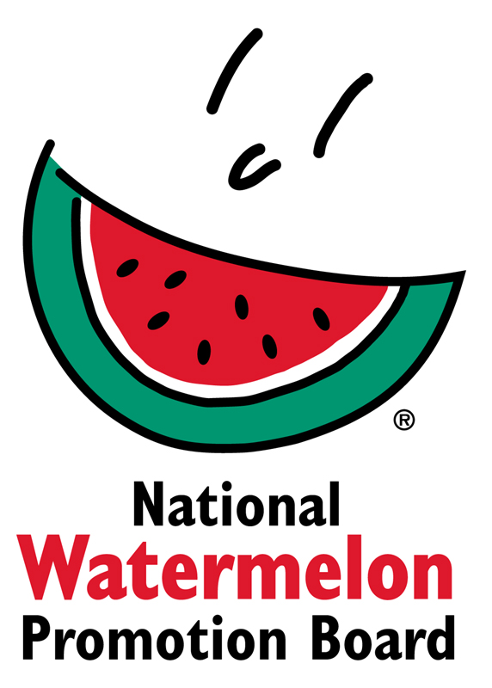

Media Contact:
Juliemar Rosado, 407-657-0261 X208
jrosado@watermelon.org

NWPB Announces 2019 Watermelon Retail Display Contest Winners
Board Awards Prizes in Two Categories:
“Classic” and “Star-Spangled” Watermelon Displays

WINTER SPRINGS, FL – October 8, 2019 – Each year throughout the months of July and August the National Watermelon Promotion Board (NWPB) hosts a Retail Display Contest to help retailers and commissaries in United States and Canada boost watermelon sales. Now in its 11th year, retailers showed a continued enthusiasm for the contest with 170 contest entries this year – up 13% over the previous year.
The goal of each display was to highlight watermelon’s health, value and versatility. Entries were judged on overall appearance, creativity, use of NWPB-provided POS materials, “shop-ability” and messaging. Of the retailers that reported to NWPB, sales year over year increased an average of 20-30%.
“Several of this year’s entries submitted more than displays,” said Juliemar Rosado, director of retail operations and international marketing. “The retailers really created an experience for shoppers in store with activities like sampling and watermelon eating contests.”
The grand prize winner in the “Classic” category is Borderland Co-Op located in Saskatchewan, Canada. The “Star-Spangled” watermelon grand prize winner is Buckland AFB Commissary in Aurora, CO. While Borderland Co-Op impressed with cooking demos for four recipes incorporating watermelon, Buckland AFB went above and beyond by hosting a watermelon eating contest.
“Co-op Food Stores across Western Canada have jumped in with both feet when it comes to participating in the NWPB Watermelon Display Contest. The creativity in displays put forth by our produce teams has generated excitement and enhanced the customer shopping experience, which increased sales volumes in participating locations,” said Nick Penry, produce retail operations manager at Federated Co-operatives Limited. “It has also resulted in several NWPB awards over the last few years. A great promotion.”
As grand prize winners, Borderland Co-Op and Buckland AFB will each receive $1,500 in prizes. Additional prizes awarded for both categories include $800 for 2nd place winners, $600 for 3rd place winners and $400 for 4th place winners, respectively. Eight honorable mentions in each category were awarded $200 each.
A complete list of the winning displays will be posted on watermelon.org. For more information, contact Juliemar Rosado at jrosado@watermelon.org.
About National Watermelon Promotion Board
The National Watermelon Promotion Board (NWPB), based in Winter Springs, Florida, was established in 1989 as an agricultural promotion group to promote watermelon in the United States and in various markets abroad. Funded through a self-mandated industry assessment paid by more than 1,500 watermelon producers, handlers and importers, NWPB mission is to increase consumer demand for watermelon through promotion, research and education programs.
Watermelon packs a nutritious punch, with each serving providing an excellent source of Vitamin C, a good source of Vitamin B6, and a delicious way to stay hydrated, with only 80 calories. Watermelon consumption per capita in the United States was an estimated 15.8 pounds in 2018. Watermelon consumption in the United States was approximately 5.2 billion pounds in 2018. The United States exported an additional 325.4 million pounds of watermelon. For additional information, visit www.watermelon.org.

###

