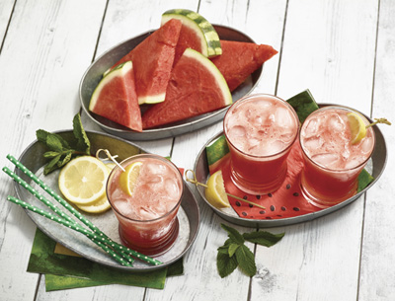
Hydrate Your Way to a Healthy Summer

Staying well-hydrated is especially important during the summer months. In addition to normal body functions, higher temperatures draw more water through perspiration, so consciously replacing your fluid content becomes essential for overall health.

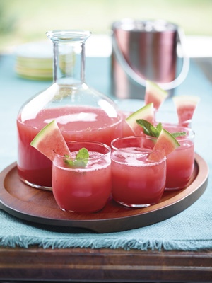
“Every system in your body – from reproduction and digestion to circulation, mood and memory – depends on water,” said Elizabeth Somer, M.A., R.D., and author of several nutrition and wellness books.

However, the Center for Disease Control and Prevention reports that 44 percent of adults drink fewer than four cups of water per day (less than half of the recommended eight glasses per day), and in some cases, no water at all.

What many people don’t realize is that beverages aren’t the only way to hydrate your body. In fact, water-dense foods such as watermelon can also boost your hydration. Sweetly flavored, low-calorie watermelon is 92 percent water and offers several nutrients along with the cancer-fighting antioxidant lycopene.

Whether eaten out of hand, tossed into a salad or blended in a healthy beverage, there are dozens of delicious ways a healthy serving of watermelon can help hydrate.

Crave-worthy snacks. Thoroughly chill the watermelon then slice, ball or cube it for a quick, refreshing and juicy boost. For kids, cut one-inch slices of the watermelon then use cookie cutters to make fun shapes for snacking.

Frozen treats. Puree watermelon, add chunks of fruit and pour into freezer molds for a sweet way to beat the heat.

Healthy juices. Make a simple Watermelon Juice for a great post-workout snack, or try this flavorful Watermelon Lemonade to put a fresh spin on a summertime favorite. Another option: add watermelon to your favorite fruit shakes or smoothies for a new flavor twist.

Salads and sandwiches. Easily add extra hydration into your regular meals by tossing chunks of watermelon into a salad or layering strips of the fruit on a sandwich or wrap.

Find more mouthwatering ideas and recipes at watermelon.org.

Watermelon Lemonade
Servings: 5 cups

1/2 cup lemon juice
2 1/2 cups water
2/3 cup agave syrup
2 cups watermelon chunks

Place all ingredients in blender and blend until smooth. Serve over ice.

Watermelon Juice
Servings: Vary, depending on watermelon size

1 watermelon, washed and cut into chunks.

Blend 2-3 cups watermelon at a time until smooth. Strain into serving pitcher, if desired.

Note: If not strained, juice will need to be stirred until blended prior to serving.

