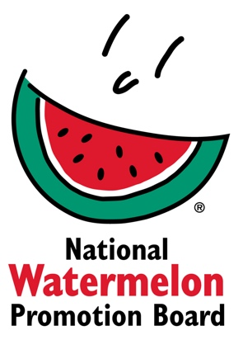
NEWS RELEASE
National Watermelon Promotion Board
FOR APPROVAL ONLY

Contact: Juliemar Rosado, Director of Retail and International Marketing
Phone: 407-657-0261 ext. 208
Email: jrosado@watermelon.org

Watermelon Board Announces Winners of the 2025 Retail Merchandising Contest

Merchandising excellence at an all-time high, with Heritage Co-op taking home the Grand Prize
Winter Springs, FL – [October XX, 2025] — The National Watermelon Promotion Board (NWPB) is proud to announce the winners of its 17th Annual Watermelon Retail Merchandising Contest, recognizing outstanding retailers who delivered creative, vibrant, and effective watermelon promotions across stores and digital platforms.
Each year, the contest celebrates retailers who use imaginative merchandising and marketing to boost watermelon sales and inspire consumers to enjoy the watermelon’s many health, value, and versatility benefits. This year’s participants truly raised the bar, with eye-catching displays, excellent cross-merchandising, and fun social media tie-ins that brought watermelon to life in fresh and exciting ways.

This year’s winners included:
- Grand Prize: Heritage Co-op – Brandon, Manitoba
- Second Place: Common Market – Frederick, MD
- Third Place (tied): KJ's Market – Hephzibah, GA; Borderland Co-op – Moosomin, Saskatchewan
- Honorable Mentions: Grocery Outlet – Shelbyville, TN; Tops Friendly Markets – Dunkirk, NY; Little Wagon Produce – Greenwood, DE; Freson Bros – Fort Saskatchewan, Alberta
“Retailers really stepped up their creativity this year,” said Juliemar Rosado, Director of Retail and International Marketing of the National Watermelon Promotion Board. “From dynamic in-store displays to new and different ways to engage with the customer, we saw fresh approaches that showcased watermelon’s many benefits while making it easy and fun for shoppers to enjoy.”
“The Produce Team at Federated Co-operatives Ltd. is so thrilled our Member Co-ops across the Co-operative Retailing System continue to show such excitement in the National Watermelon Promotion Board merchandising contest each year,” said Joshua Hubert, Senior Manager, Produce Operations for Federated Co-operatives Limited. “We continue to see exciting and award-winning displays that highlight everyone’s summer favorite of watermelon, and delight our guests. A big congratulations to Tyler and his team in Heritage Co-op, and Kim and her team at Borderland Co-op. We look forward to participating again next year!”
More than $10,000 in cash and prizes will be awarded to winners, including $5,000 for Heritage Co-op as the grand prize winner. The second place winner will receive $2,500, each third place winner will receive $1,000 and each of the four honorable mentions will receive $500.
A complete list of the winners with images will be posted on https://www.watermelon.org/audiences/retailers/retail-contest/. For more information, contact Juliemar Rosado at jrosado@watermelon.org.
###

About the National Watermelon Promotion Board
The National Watermelon Promotion Board (NWPB), based in Winter Springs, Florida, was established in 1989 as an agricultural promotion group to promote watermelon in the United States and in various markets abroad. Funded through a self-mandated industry assessment paid by nearly 700 watermelon producers, handlers and importers, NWPB mission is to increase consumer demand for watermelon through promotion, research and education programs.
A serving of nutrient-dense watermelon provides an excellent source of Vitamin C (25% DV), a source of Vitamin B6 (8% DV), and a delicious way to stay hydrated (92% water), with only 80 calories per 2-cup serving. Watermelon consumption per capita in the United States was roughly 15.6 pounds in 2024. Watermelon consumption in the United States was nearly 5.3 billion pounds in 2024. Additionally, the United States exported 400 million pounds of watermelon. For additional information, visit www.watermelon.org.

